Long-Distant Intentions

During meditation in most cases we see decrease of Sputnik signal, but in some cases, we record increase.

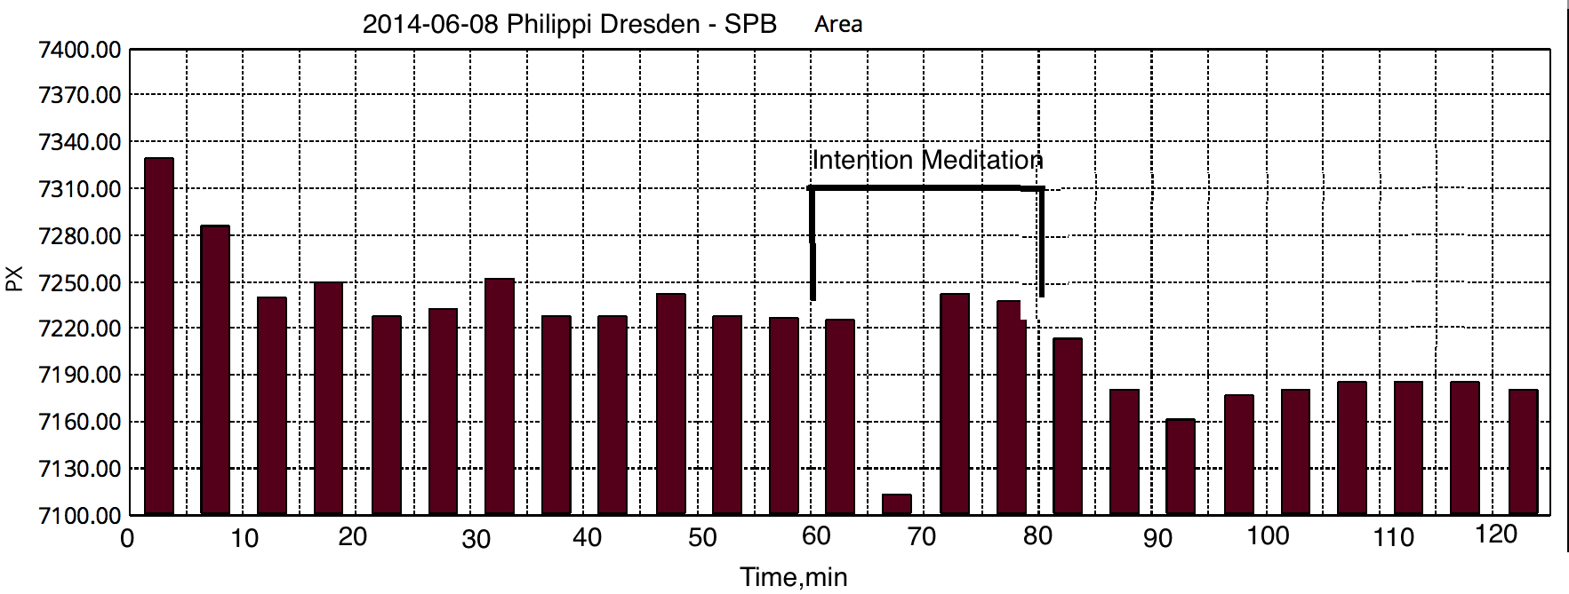
Clear effect of distant meditation Dresden – SPb – decrease of signal.

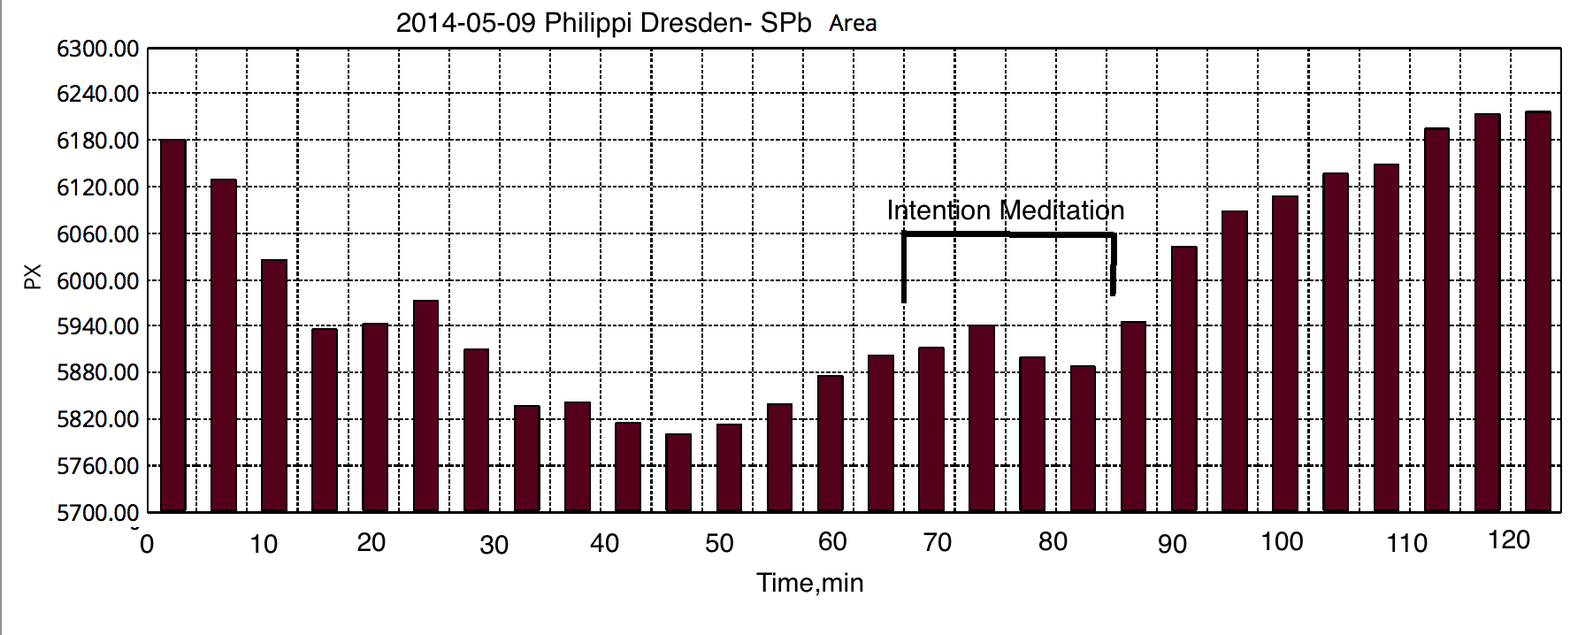
Clear effect of distant meditation Dresden – SPb – increase of signal.

